WiFi-Controlled Programmable DC Load Update

Avoid Kelvin sensing until unit is modified
It is strongly recommended that the Kelvin voltage sensing function of the DC load is not used until the modifications outlined in this article have been completed. Normal voltage sensing, via the main + and – terminals is unaffected by this issue.
The WiFi Controlled DC Load project has proved popular, and constructors have suggested a number of worthwhile hardware and software improvements. Two stand out, principally Erwin Bejsta’s improvements to the battery test function, and Ray Miller’s analysis that showed that the original Kelvin voltage sensing arrangements could potentially damage the ADS1115 ADC at high currents. There is no issue if the main + and – terminals are used for voltage sensing.
The hardware changes
- Kelvin sensing issue rectified
- Reduced noise in the 12v supply
- Less control sensitivity to short-term current transients

While the full list of software changes is available in the changelog <link> the highlights are:
- Multiple improvements to battery testing
- Kelvin sensing modes added
- More accurate and rapid control behaviour, particularly in CR, CP and CV modes.
- Improved error condition monitoring (over/under voltage, over current, exceeding AOA).
- Screen rotation now supported as well as touch panel rotation.
Several other constructors have made suggestions that have been included in a software update which is downloadable from <link> and a revised manual is available at <link>.

Hardware improvements
The main improvement to the hardware resolves the issue with Kelvin voltage sensing. This change is mandatory if Kelvin (4-wire) voltage sensing is to be used.
The other changes require one or two components to be added or changed: improvements to noise on the 12V supply rail to the opamps; a reduction in sensitivity to current transients in ESP32 readings and a reduction to ringing in the DAC output under step changes.

Kelvin sensing modifications
Some additional circuitry is required to rectify the issue with Kelvin voltage sensing. In the original circuit, the negative Kelvin sensing terminal is connected directly to the negative input of the ADS1115. If Kelvin sensing is being used and there is significant resistance in the lead from the DUT to the main negative input, the negative Kelvin terminal develops a potential below system ground (see Fig.1).
If the load current is 10A, just 0.1 ohms resistance in the negative power lead will create a -1.0V potential at the ADS1115 negative voltage sensing pin and destructive current will flow, as the protection diodes in the ADS1115 are only rated at 10mA.
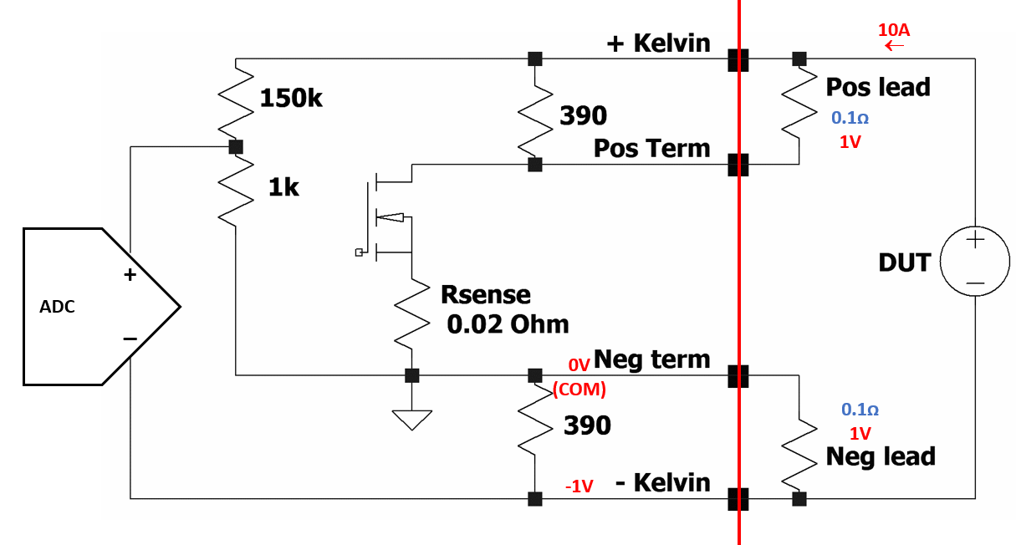
Fig.1 Simplified circuit of the original DC Load final stage and Kelvin sensing. When substantial current is flowing, any resistance in the negative lead to the DUT will induce a negative voltage directly at the ADC negative input.
To resolve this issue, a voltage divider is inserted into the negative side of the voltage sensing circuit and both positive and negative sides are biased to 0.7V (see Fig.2). This is sufficient to maintain both ADS inputs within acceptable values for normal operations.
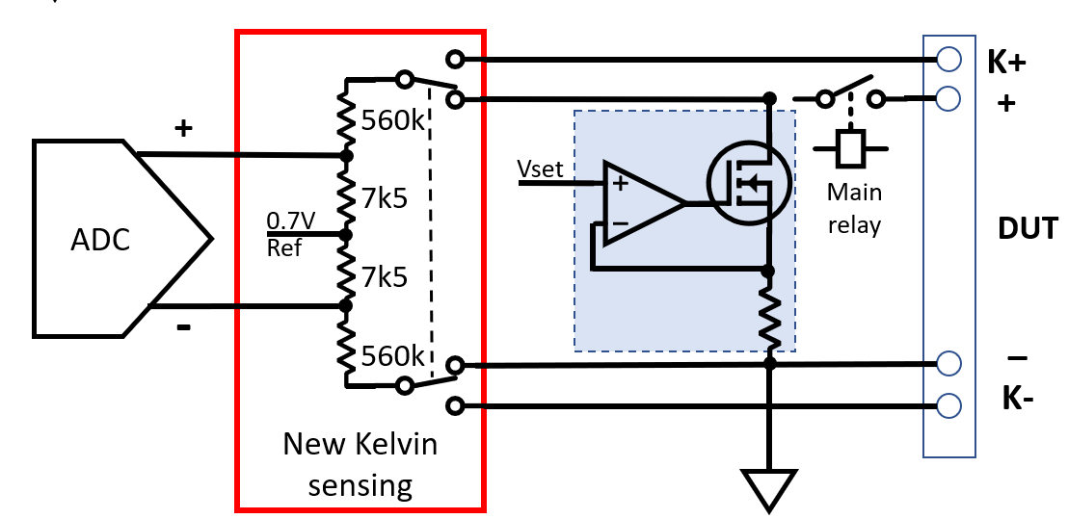
Fig.2 With a voltage divider in the negative Kelvin sensing leg, with -150V applied directly to the K- input, the current through the voltage divider is around 250uA, well with in the 10mA rating of the ADS1115input protection diodes.
The worst-case fault conditions are when the main negative terminal is disconnected. If the DUT provides 150V, the Kelvin terminal will be at -150V and the divider current is around 0.25 mA, well within spec for the ADS’ internal protection diodes.
A DPDT relay switches between the main and Kelvin voltage sensing terminals, removing any connection between them. The relay is driven by GPIO-16 via transistor Q1.
There are three voltage sensing modes available on the SET menu in the updated code: Main, Kelvin and Auto.
When the load is OFF, voltage is always sensed via the main terminals. With no current flowing, this will be the same value as the Kelvin terminals if they are connected.
When transitioning to ON, a measurement is taken on the Kelvin inputs. In Auto mode, if the voltage is close to the voltage across the main terminals, then Kelvin sensing is used. In Kelvin mode, if an equivalent voltage is not read an error is triggered and the load does not switch on.
The new circuitry in Fig.3 fits on Veroboard, Fig.4, which can be mounted near the relay board in the bottom of the case. There is no capacitor from K- to GND on the circuit as there is already a 1n MLCC in this location on the main Load PCB.
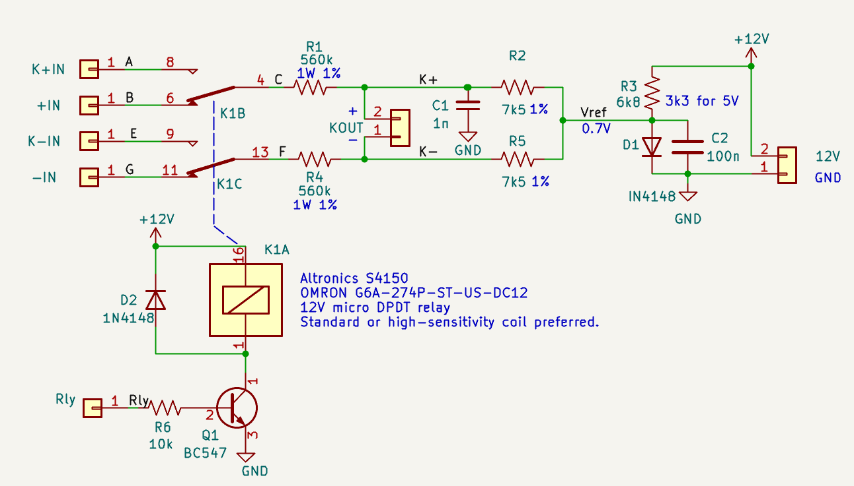
Fig.3 The components for the small cirucit containing the revised Kelvin sensing input circuitry. Through-hole components have been used to simplify parts sourcing.
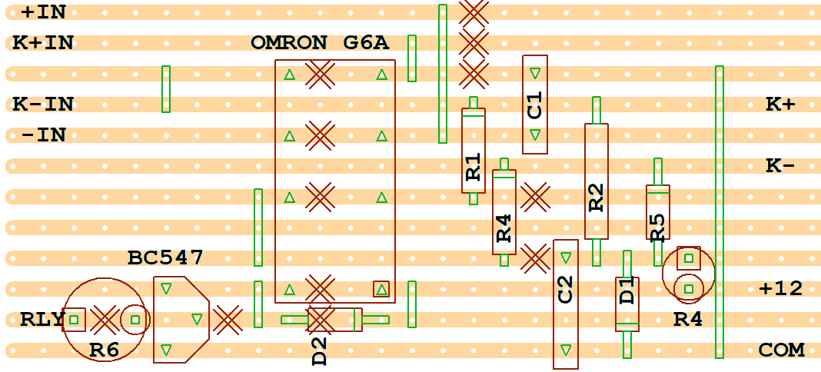
Fig.4 A Veroboard layout made with VeeCAD. The X marks are cut tracks. Green rectangles are links.
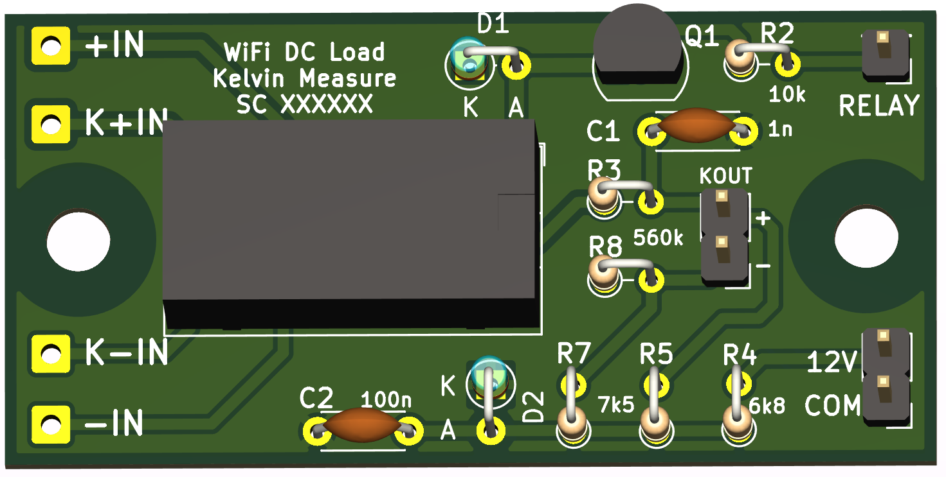
Fig.4 Alternately, the Gerber files for a 25mm x 51mm PCB are included in the repository.
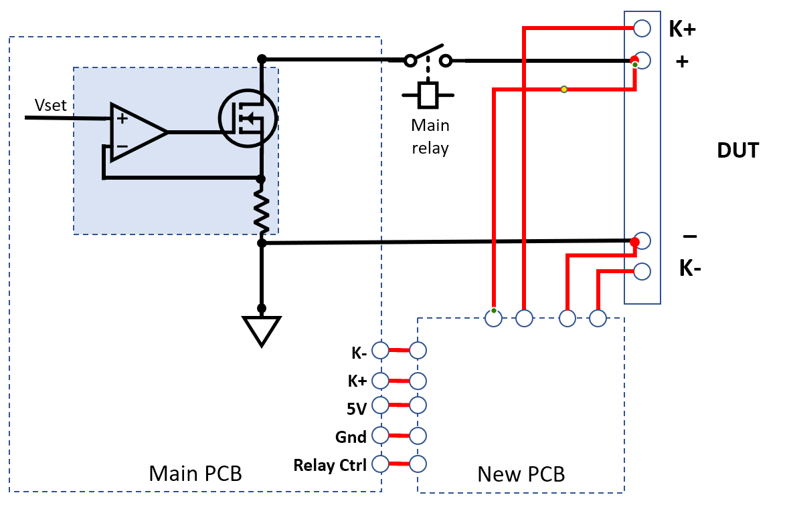
Fig.5 The new Kelvin sensing arrangements re-route the Kelvin sensing input wires and source additional signals from the main PCB.

Construction
Through-hole parts have been specified throughout to simplify sourcing.
The DPDT micro relay has an Omron G6V footprint and drop in replacements are available from Altronics and other parts suppliers.
The 560K resistors need to be 1W types for their higher breakdown voltage. These and the 7.5K resistors in the voltage dividers are the only critical values in the circuit.
While we have designed a small PCB for this modification, Veroboard is a viable alternative.
The modifications to the main PCB are straightforward – the 100k ohm resistor in Figs 5 and 6 is bridged and the 1.2k ohm resistor removed. A 330pF capacitor is soldered between the base of Q5 and ground.
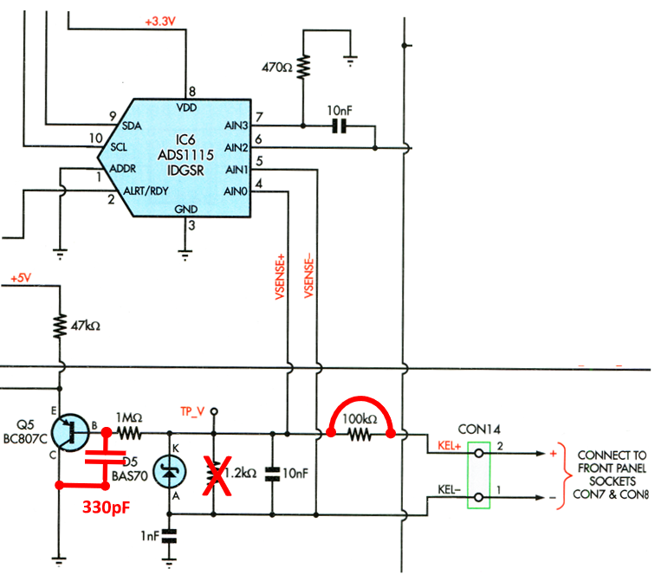
Fig.5 On the main PCB, one resistor is removed and one is bridged. A 330pF capacitor is added at the base of Q5 to reduce input noise to the ESP32 ADC.
The two existing 100 ohm resistors between the front panel Kelvin sensing and main input terminals are also removed.
While none of the wiring will carry any substantial currents, the + side wires coming from the front panel may be carrying up to 150V, requiring adequate insulation.
The two wires coming from the Kelvin terminals on the front panel are transferred to the new PCB (K+IN and K-IN pads) and the KOUT pads of the new PCB go to the main PCB’s Kelvin terminals.
The four input pads on the left-hand side of the board connect directly to their respective front panel terminals.
The relay signal comes directly from pin 8 of the Control connector, 12V and COM are available on the main PCB. The Relay pins on the main PCB are a convenient source.
After connecting all the cables to the small PCB, mount it in the base of the case, next to the main relay board.

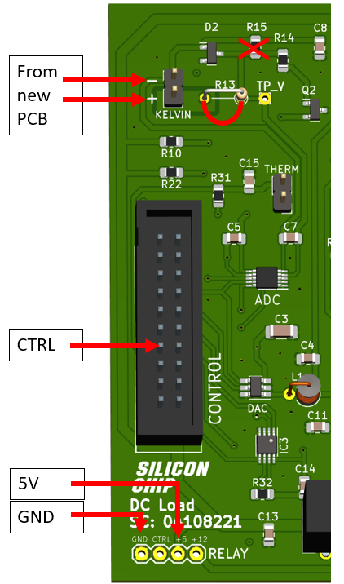
Fig.7 A visualisation of the main PCB alterations.

Current transients
Ray Miller detected load current transients, followed by ringing in the current control cycle, that were triggered by false current readings by the ESP32 ADC (see Scope.1). The deviations from the correct value are +/- 30mV indicating a current variation of just over 0.5A.
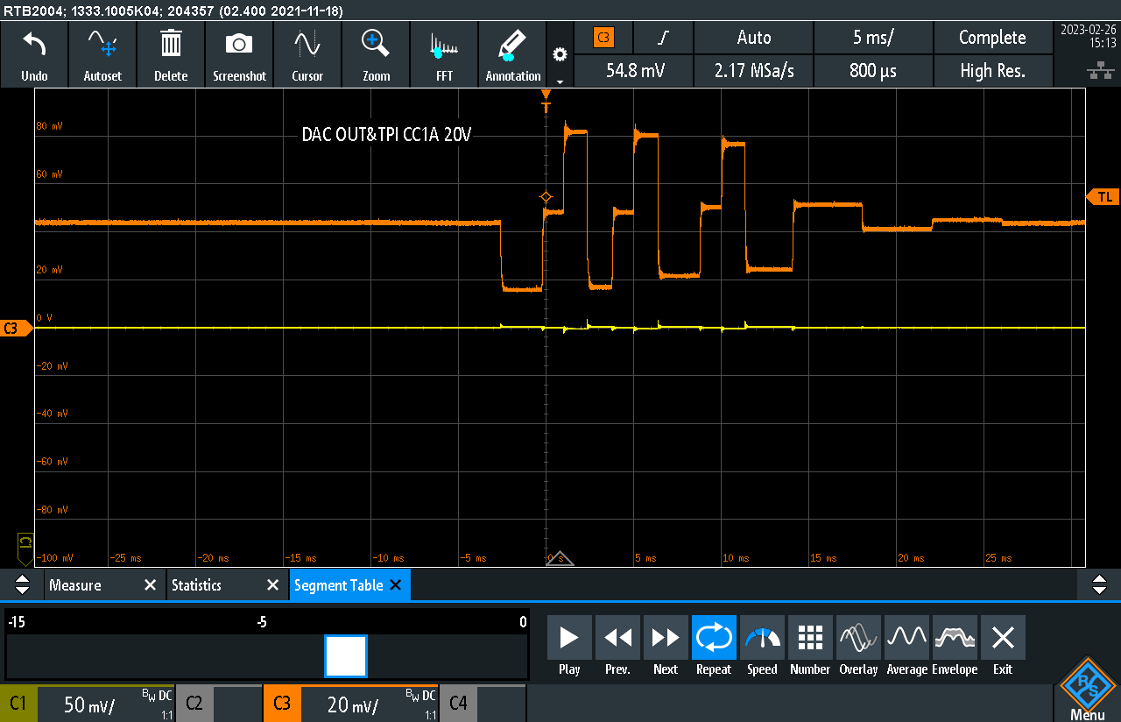
Scope.1 Ray Miller’s capture of the current waveform resulting from the transient ESP32 current reading. The orange trace is the current at test point TP-I and the yellow trace is the voltage at TP-V. The vertical resolution is 20mV/div and horizontal 5mS/div.
The main ADS1115 ADC completes a set of readings every 2.3mS. In between these cycles the ESP32’s ADC is used to check that there hasn’t been a substantial change to current or voltage that needs immediate attention. In the scope trace, Scope.1, a transient high current reading by the ESP32 ADC, around 3mS before the cursor on the screen, caused a substantial downward change to the DAC current setting, as shown in the top trace. The next ADS sample corrected the issue; however the control loop was not sufficiently damped and it took several control cycles before the output settled.
The issue has been rectified in software: the current difference that will cause an immediate update after a substantially different ESP32 reading has been increased from 0.4A to 5A. While the new value may seem large, instantaneous current control is managed by the op amp driving each MOSFET and the ESP32 ADC readings are mainly intended for more immediate response to short-circuits.
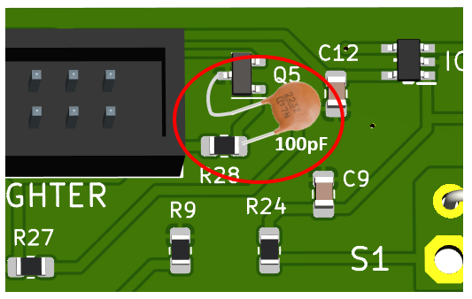
Fig.6 100pF is added between the base of Q5 and ground on the main PCB to reduce transients in the ESP32 ADC current signal.
To further reduce the sensitivity to transients, Ray Miller’s suggestion of a small (100pF) capacitor from the base of Q5 to ground (see Fig.X) offers a worthwhile improvement.

Power supply noise
The fans on the CPU coolers produce quite a lot of electrical noise. While there is no observed connection to the load’s performance, decoupling the 12V supply to the op amps from the 12V input could be useful. The12V track (see Fig.X) on the rear of the main PCB is broken and a ferrite bead is inserted into the 12V line. Next to it, add 1uF MLCC from the decoupled track to ground.
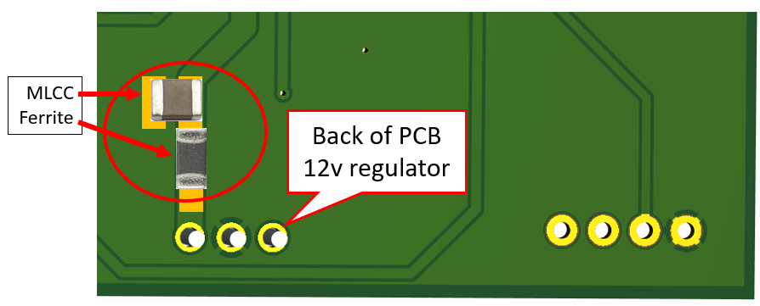
Fig.x On the underside of the PCB, break the 12V track near the pin of the regulator and insert a ferrite bead across the gap. A 1uF MLCC provides extra filtering of the decoupled supply.

Opamp output
Another of Ray’s observations was that the input to the opamps exhibited some ringing under step changes (Scope.2) at the resonant frequency of L1 and C4 . Replacing the choke with a 47 ohm resistor rectifies the issue.

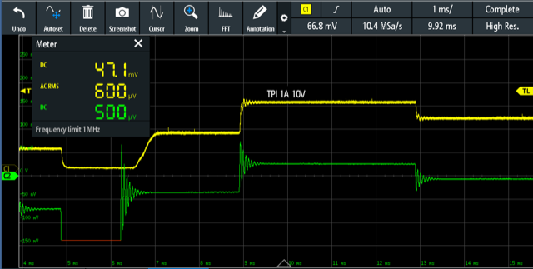
Scope.2 Ringing at the input to the opamps due to L1 and C4

Software improvements

Battery test improvements
There are three main improvements in the battery testing code, none of which require any circuit modifications.
Occasionally the battery test would drop out early due to a single voltage measurement below the test completion setting. Now the code averages several readings before deciding whether the final voltage has been reached.
The screen summarising the results of the battery test previously disappeared after 10 seconds, which was not optimal for unattended testing. Now the summary screen remains visible until the user touches the screen.
The measurement logging rate has been decreased is now able to be set via the logging interval (LI) setting (1 to 999,998 seconds) and the buffer size increased, allowing hundreds of hours of test duration before values start to be overwritten in the circular log buffer.

Screen rotation
Several constructors noted that their screen displays were upside down, requiring re-compiled code to be provided. An option in the CAL menu is now available for rotating the screen display as well as the touch panel.

Parts List
1 double-sided PCB coded 1234567, 24 x 42mm
1 micro DPDT relay with 12V coil (Omron G6A-274P-ST-US-DC12, Altronics S4150)
2 GP silicon diode, 1N4148 or similar
1 NPN GP transistor (CBE), BC4547 or similar
2

Resistors (All 1/4 W metal film, 5% or better unless noted)
3 7.5k, 1%
1 6.8k
1 10k
2 560k, 1%

Capacitors (radial ceramic)
1 1 nF
1 100 nF
1 330 pF

General improvements
The fans create significant electrical noise on the 12V supply and some of the high frequency components of the noise find their way through the op amps to the MOSFET gates. A small, 50-150uH RF choke and 10uF MLCC are inserted into the supply line as shown in Fig.x to isolate the 12V supply to the analogue portions of the circuit.
The choke at the output of the DAC which reduces supply line noise on the control signal also causes some ringing during step changes. It can be substituted by a 100 ohm resistor to eliminate the ringing.
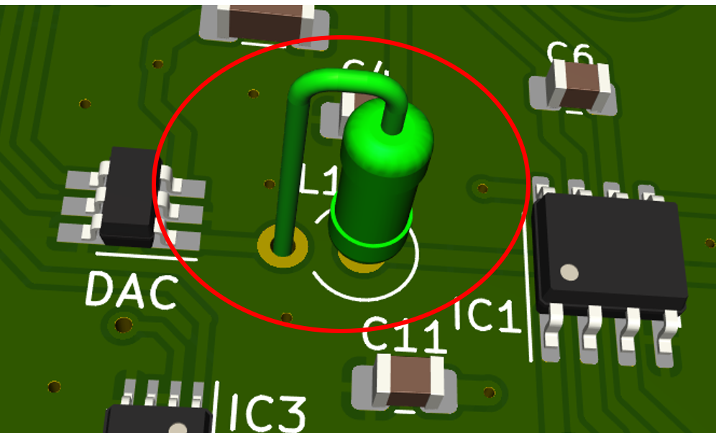
Fig.x The inductor on the output of the DAC is replaced by a 100 ohm resistor to eliminate ringing during step changes.
Jaycar LF1534
10uF 25V MLCC
100 ohm ¼W resistor

Open-source code
Several constructors have asked for the code to be made available, so that they can improve or extend it. The original and improved code, as well as compiled binaries, are now available at https://github.com/palmerr23/ESP32-DCLOAD Compiling from source, however, is not for the faint hearted!

